**Linear Mixed Effects Modelling - Assignment 4**

Nicole Ponto (B00871580)

Department of Psychiatry, Dalhousie University

PSYR 6003: Statistics

Dr. I. Yakovenko

April 26, 2024

**Results**

The dataset used for this study consisted of a sample of 263 people that were measured using a daily questionnaire once a day for up to 20 days. For this analysis three subscales measuring extraversion, neuroticism, and life satisfaction were used. The goal of this study is to test a model where extraversion and neuroticism are predictors, and the dependent variable is life satisfaction. To do this, the following hypotheses were investigated using a linear mixed effects model. H1: Extraversion will be positively associated with life satisfaction. H2: Neuroticism will be negatively associated with life satisfaction. H3: The effects will be similar for both level 1 (within participants over time) and level 2 (between participants).

**Data Cleaning**

Data was cleaned to remove any missing values and then visually inspected to assess if the three subscales were varied within clusters. The neuroticism, extraversion, and life satisfaction scores changed over time (in the cluster) and therefore were initially assumed to have random effects (this assumption will be tested in a model comparison later in the analysis).

**Primary Analysis**

Univariate relationships were visualized (Fig 1A), all figures appeared to be relatively normally distributed and there were no serious concerns for outliers based off visual inspection of the distribution.

**Hypothesis 1 and 2**

As a part of the linear mixed effects model, full and reduced models were used to visualize the univariate and bivariate distributions associated with H1: Extraversion will be positively associated with life satisfaction. Full model: Life Satisfaction = b0 + b1*Extraversion + r1*Extraversion + r0 + e. Reduced Model: Life Satisfaction = b0 + r0 + e. A comparison between the full and reduced models showed that the full model (AIC = 10553.52, BIC=10585.28, Bayes Factor = 3.67 e+157) fits more closely than the reduced model (AIC = 11291.84, BIC = 11310.90, Bayes Factor = 0). The lower AIC/BIC values and high level of Bayes Factor support the full model. When comparing the fixed model (AIC= 10936.75, BIC = 10962.16, Bayes Factor = 0) to the random model (AIC = 10856.82, BIC = 10894.94, Bayes Factor 3.94 e+14) the lower AIC/BIC values and high level of Bayes Factor in the random model indicate support for random mixed effects. As seen in table 1B, the model predicts 16% of the variance in the model, which supports the hypothesis that Extraversion will be positively associated with life satisfaction.

To investigate the second hypothesis, the linear mixed effects model was used. Full and reduced models were used to visualize the univariate and bivariate distributions associated with H2: Neuroticism will be negatively associated with life satisfaction. Full Model: Life Satisfaction = b0 + b1* Extraversion + b2*Neuroticism + r1*Extraversion + r2* Neuroticism + r0 + e. Reduced Model: Life Satisfaction = b0 + b1*Extraversion +r1*Extraversion + r0 + e. A comparison between the full and reduced models showed that the full model (AIC = 10355.86, BIC=10419.39, Bayes Factor = 9.238+e24) fits more closely than the reduced model (AIC = 10489.89, BIC = 10534.36, Bayes Factor = 0). The lower AIC/BIC values and high level of Bayes Factor support the full model. As seen in table 1, the model predicts that -21% of the variance, which supports the hypothesis that neuroticism will be negatively associated with life satisfaction.

**Hypothesis 3**

Hypothesis 3 posits that the effects will be similar for both level 1 (within participants over time) and level 2 (between participants). For this a model comparison was made between a reduced model (Life Satisfaction = b0 + b1*Extraversion + B2*Neuroticism + r0 + e) and a full model (Life Satisfaction = b0 + b1*Extraversion + B2*Neuroticism + r1*Extraversion + r2*Neuroticism+ r0 + e). A comparison between the full and reduced models showed that the full model (AIC = 10355.86, BIC=10419.39, Bayes Factor = 1.05 e+36) fits more closely than the reduced model (AIC = 10553.52, BIC = 105.85.28, Bayes Factor = 0). The lower AIC/BIC values and high level of Bayes Factor support the full model. The findings were visualized (Fig 2A + 3A) and show similar trends across the identifying clusters (levels). If estimates could be calculated the amount of variance would be known (R studio was not working so the code is available but is not functional). When looking at the marginal *R2* (0.094) compared to the conditional *R2* (0.789). As these effects are found to be similar, along with the visual confirmation found in Figures 2A and 3A by the colored lines. This evidence supports the hypothesis that the effects of the model will be similar for level 1 (within participants over time) and level 2 (between participants).

**Appendix A**

Figures associated with the analysis of the dataset.

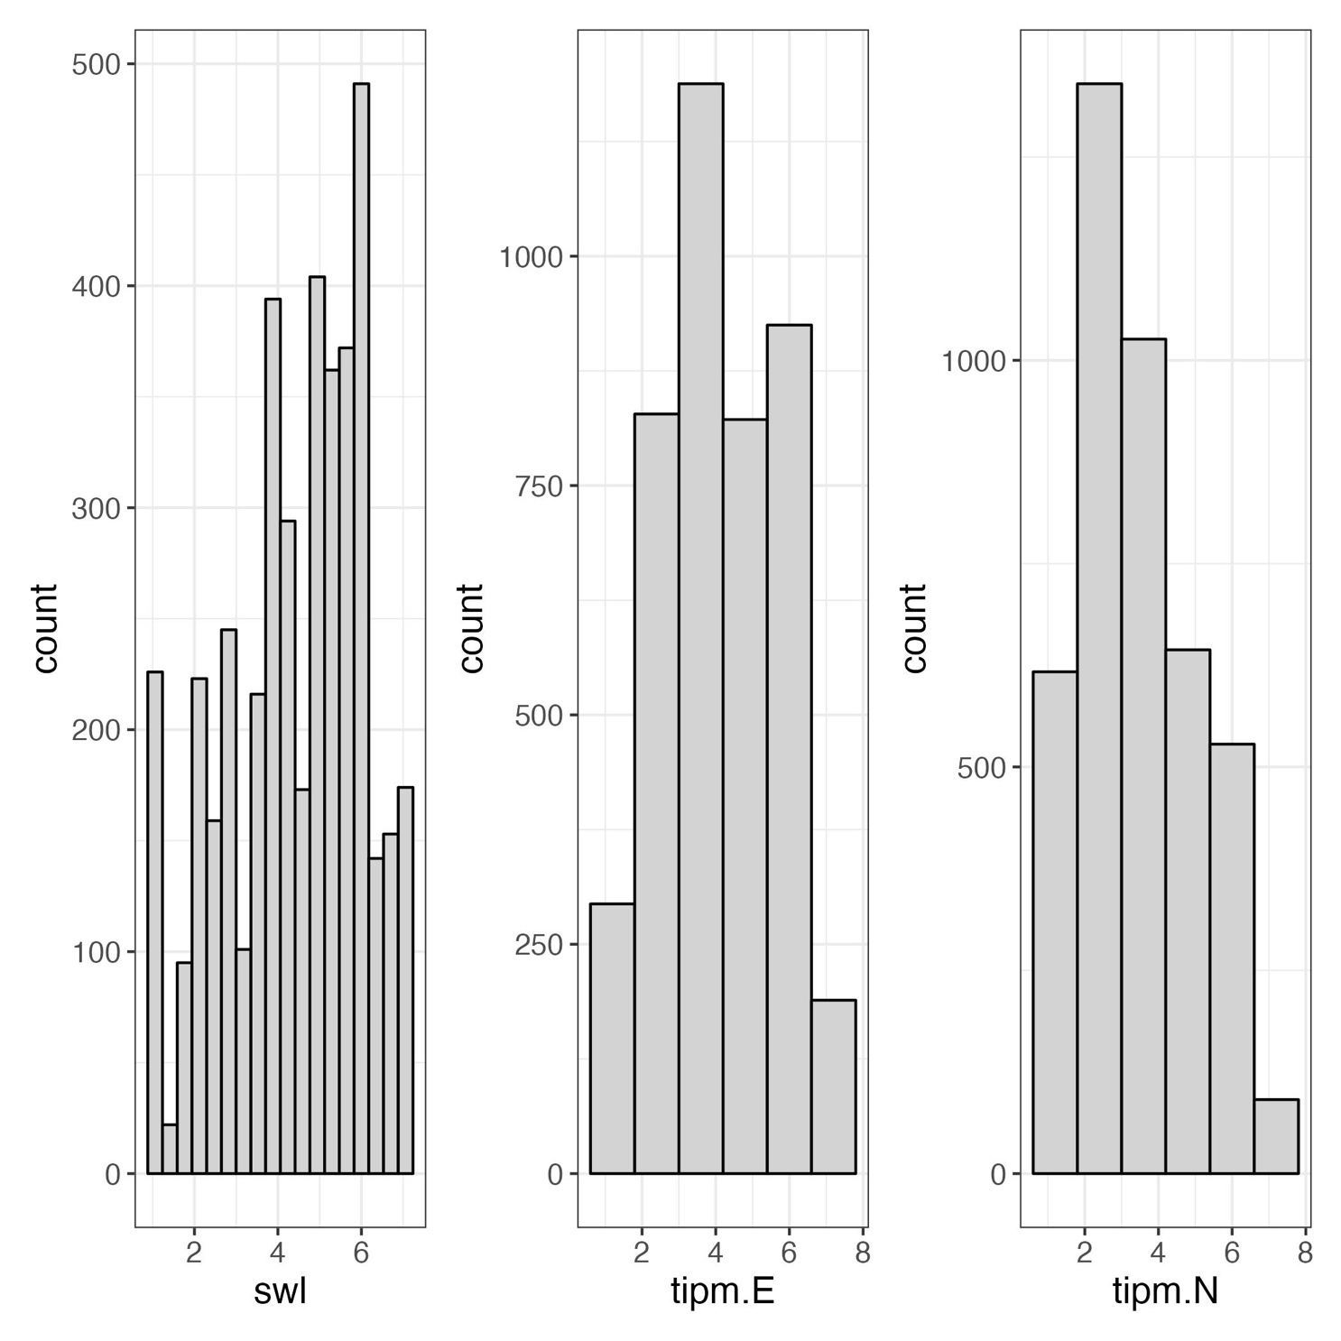Figure 1A: Univariate Relationships in Life Satisfaction (swl), Extraversion (tipm.E), and Neuroticism (tipm.N)

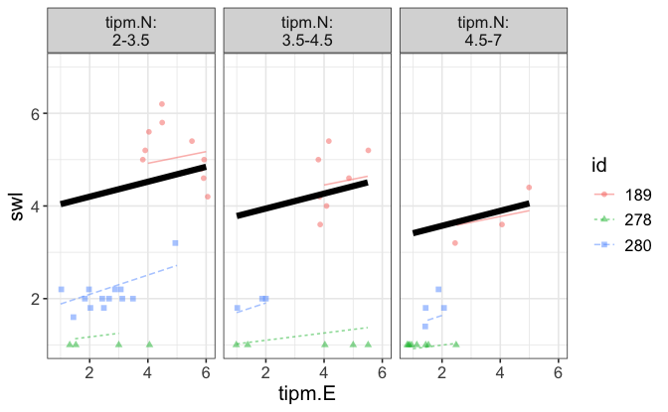Figure 2A: Visualization of model where life satisfaction (swl) is a dependent variable to predictors Extraversion (tipm.E) and neuroticism (tipm.N). The black line shows the fixed effect, and the colored lines display individual trajectories.

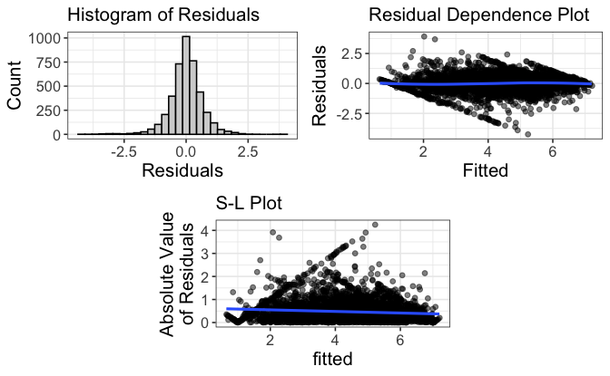Figure 3A: Visualization of residuals for model where extraversion and neurotiscsm predict life satisfaction using random mixed effects.

**Appendix B**

Tables associated with dataset.

Table 1B

*Mixed Effect Model Results using Life Satisfaction as the Criterion*

|  |  |  |  |  |  |
| --- | --- | --- | --- | --- | --- |
| Predictor | *b* | *b*  95% CI  [LL, UL] | Fixed Effect*s* | *SE* | Fit |
| (Intercept) | 4.55** | [4.27, 4.74] |  | 0.18 |  |
| Extraversion | 0.16** | [0.13, 0.19] |  | 0.02 |  |
| Neuroticism | -0.22 | [-0.24, -0.18] |  | 0.01 |  |
|  |  |  |  |  |  |
|  |  |  |  |  | *R2* Intercept / Residual = -0.06/ -0.26 |
|  |  |  |  |  | ICC = 0.77 |
|  |  |  |  |  |  |

Predictor Random Effects

Variance SD Fit

|  |  |  |  |  |  |
| --- | --- | --- | --- | --- | --- |
|  |  |  |  |  |  |
| (Intercept) | 2.02 | 1.53 |  |  |  |
| Extraversion | 0.02 | 0.17 |  |  |  |
| Neuroticism | 0.04 | 0.19 |  |  |  |
| Residual | -0.41 | 0.75 |  |  | *Marginal R2*  / Conditional *R2* = .094/0.789 |
|  |  |  |  |  |  |

*Note.* B represents the fixed effects estimates. SE represents the standard errors of the estimates. *LL* and *UL* indicate the lower and upper limits of a confidence interval, respectively. *R2* represents the coefficient of determination. ICC represents the intraclass correlation coefficient. SD represents the standard deviation.

* indicates p < .05. ** indicates p < .01.